Filed by American Water Works Company, Inc.
pursuant to Rule 425 under the Securities Act of 1933
and deemed filed pursuant to Rule 14a-6
under the Securities Exchange Act of 1934
Subject Company: Essential Utilities, Inc.
Commission File No.: 001-06659
Date: July 29, 2026
The following statement regarding the merger between American Water Works Company, Inc. (“American Water”) and Essential Utilities, Inc. (“Essential Utilities”) was included in American Water’s earnings press release issued on July 29, 2026.

 |  |  | Progress continues on proposed merger with Essential Utilities; three states have approved, settlement in principle reached in Texas, and integration planning progressing
The following communication regarding the merger between American Water and Essential Utilities was included in earnings materials first made public by American Water on July 29, 2026.

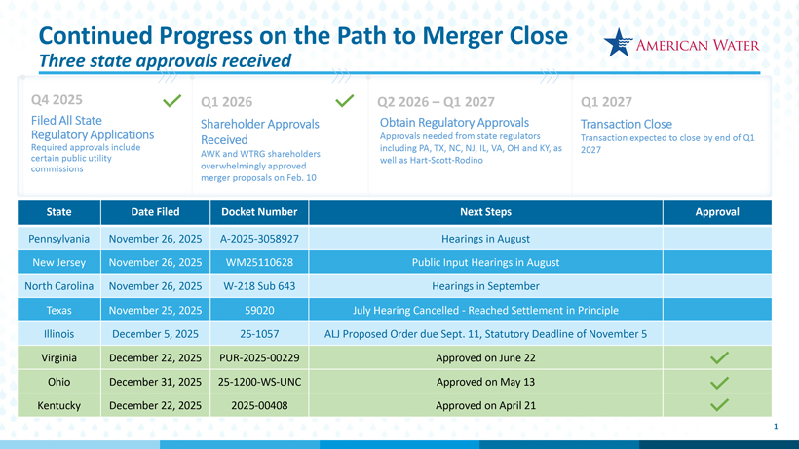
The following communication regarding the merger between American Water and Essential Utilities was included in an email sent by John Griffith, President and Chief Executive Officer of American Water, to employees of American Water on July 29, 2026.
The achievements so far this year are even more remarkable when we consider that all of this work has been done alongside our planned integration and merger with Essential Utilities. We have received three state regulatory approvals so far with a settlement in principle in Texas and remain on track to close in the first quarter of 2027.
Cautionary Statement Regarding Forward-Looking Statements
Certain statements included in this communication are forward-looking statements within the meaning of Section 27A of the Securities Act of 1933, as amended, Section 21E of the Securities Exchange Act of 1934, as amended, and the Private Securities Litigation Reform Act of 1995. In some cases, these forward-looking statements can be identified by words with prospective meanings such as “intend,” “plan,” “estimate,” “believe,” “anticipate,” “expect,” “predict,” “project,” “propose,” “assume,” “forecast,” “outlook,” “future,” “likely,” “pending,” “goal,” “objective,” “potential,” “continue,” “seek to,” “may,” “can,” “will,” “should” and “could,” or the negative of such terms or other variations or similar expressions. Forward-looking statements may relate to, among other things: statements about the benefits of the proposed merger, including future financial and operating results; the parties’ respective plans, objectives, expectations and intentions; the expected timing and likelihood of completion of the merger and related transactions; the results of any strategic review; expected synergies of the proposed merger; the timing and result of various regulatory proceedings related to the proposed merger, and other general rate cases, filings for infrastructure surcharges and other governmental agency authorizations and proceedings, and filings to address regulatory lag; the combined company’s ability to execute its current and long-term business, operational, capital expenditures and growth plans and strategies; the amount, allocation and timing of projected capital expenditures and related funding requirements; the future impacts of increased or increasing transaction and

financing costs associated with the proposed merger or otherwise, as well as inflation and interest rates; each party’s ability to finance current and projected operations, capital expenditure needs and growth initiatives by accessing the debt and equity capital markets and sources of short-term liquidity; impacts of the proposed merger on the future settlement or settlements of a party’s forward sale agreements, including potential adjustments to the forward sale price or other economic terms thereunder, and the amount of and the intended use of net proceeds from any such future settlement or settlements; the outcome and impact on other governmental and regulatory investigations; the filing of class action lawsuits and other litigation and legal proceedings related to the proposed merger; the ability to complete, and the timing and efficacy of, the design, development, implementation and improvement of technology and other strategic initiatives; each party’s ability to comply with new and changing environmental regulations; regulatory, legislative, tax policy or legal developments; and impacts that future significant tax legislation may have on each such party and on its business, results of operations, cash flows and liquidity.
These forward-looking statements are predictions based on currently available information, the parties’ current respective expectations and assumptions regarding future events that American Water Works Company, Inc. (“American Water”) and Essential Utilities, Inc. (“Essential Utilities”) believe to be reasonable. They are not, however, guarantees or assurances of any outcomes, performance or achievements, and readers are cautioned not to place undue reliance upon them. You should not regard any forward-looking statement as a representation or warranty by American Water, Essential Utilities or any other person that the expectation, plan or objective expressed in such forward-looking statement will be successfully achieved in any specified time frame, or at all. The forward-looking statements are subject to a number of estimates and assumptions, and known and unknown risks, uncertainties and other factors. Actual results may differ materially from those discussed in the forward-looking statements included in this communication as a result of the factors discussed in American Water’s Annual Report on Form 10-K for the year ended December 31, 2025, as filed with the Securities and Exchange Commission (the “SEC”) on February 18, 2026 (available at: ir.amwater.com), Essential Utilities’ Annual Report on Form 10-K for the year ended December 31, 2025, as filed with the SEC on February 26, 2026 (available at: essential.co), and each party’s other filings with the SEC, and additional risks and uncertainties, including with respect to (1) the parties’ ability to consummate the proposed merger pursuant to the terms of the definitive merger agreement or at all; (2) each party’s requirement to obtain required governmental and regulatory approvals required for the proposed merger (and/or that such approvals may result in the imposition of burdensome or commercially undesirable conditions, including required dispositions, that could adversely affect the combined company or the expected benefits of the proposed merger); (3) an event, change or other circumstance that could give rise to the termination of the merger agreement; (4) the failure to satisfy or waive a condition to closing of the proposed merger on a timely basis or at all; (5) a delay in the timing to consummate the proposed merger; (6) the failure to integrate the parties’ businesses successfully; (7) the failure to fully realize benefits, efficiencies and cost savings from the proposed merger or that such benefits, efficiencies and cost savings may take longer to realize or be more costly to achieve than expected; (8) negative or adverse impacts of the announcement of the proposed merger on the market price of American Water’s or Essential Utilities’ common stock; (9) the risk of litigation, legal proceedings or other challenges related to the proposed merger; (10) disruption from the proposed merger making it more difficult to maintain relationships with customers, employees, contractors, suppliers, regulators, vendors, elected officials, governmental agencies, or other stakeholders; (11) the diversion of each party’s management’s time and attention from ongoing business operations and opportunities of such party on merger-related matters; (12) the challenging macroeconomic environment, including disruptions in the water and wastewater utility industries; (13) the ability of each party to manage its respective existing operations and financing arrangements on favorable terms or at all, including with respect to future capital expenditures and investments, operations, and maintenance costs; (14) changes in environmental laws and regulations regarding each party’s respective operations that may adversely impact such party’s businesses or increase the cost of operations; (15) changes in each party’s key management and personnel; (16) changes in tax laws that could adversely affect beneficial tax treatment of the proposed merger; (17) regulatory, legislative, local or municipal actions affecting the water and wastewater industries, which could adversely affect the parties’ respective utility subsidiaries; and (18) other economic, business and other factors, including inflation, interest rate fluctuations or tariffs. The foregoing factors should not be construed as exhaustive.
These forward-looking statements are qualified by, and should be read together with, the risks and uncertainties set forth above and the risk factors included in American Water’s and Essential Utilities’ respective annual and quarterly reports as filed with the SEC and in the definitive joint proxy statement/prospectus, as filed with the SEC on December 31, 2025 (available at: https://www.sec.gov/Archives/edgar/data/1410636/000119312525337598/d15683d424b3.htm), and readers

should refer to such risks, uncertainties and risk factors in evaluating such forward-looking statements. Any forward-looking statements speak only as of the date this communication is first used or given. Neither American Water nor Essential Utilities has any obligation or intention to update or revise any forward-looking statement, whether as a result of new information, future events, changed circumstances or otherwise, except as otherwise required by the federal securities laws. New factors emerge from time to time, and it is not possible for American Water or Essential Utilities to predict all such factors. Furthermore, it may not be possible to assess the impact of any such factor on American Water’s or Essential Utilities’ businesses, viewed independently or together, or the extent to which any factor, or combination of factors, may cause results to differ materially from those contained in any forward-looking statement.
Proposed Merger
For additional information regarding the proposed merger, please see American Water’s registration statement on Form S-4 (Registration No. 333-292182), which was declared effective by the SEC on December 30, 2025, and the other documents that American Water or Essential Utilities has filed or may file with the SEC.
No Offer or Solicitation
This communication is for informational purposes and is not intended to, and shall not, constitute an offer to sell or the solicitation of an offer to buy any securities, nor shall there be any offer or sale of securities in any jurisdiction in which such offer, solicitation or sale would be unlawful prior to registration or qualification under the securities laws of any such jurisdiction. No offering of securities shall be made except by means of a prospectus meeting the requirements of Section 10 of the Securities Act of 1933, as amended.

